**Final Assignment – Part 1**

**Screenshot of Database in PyCharm**

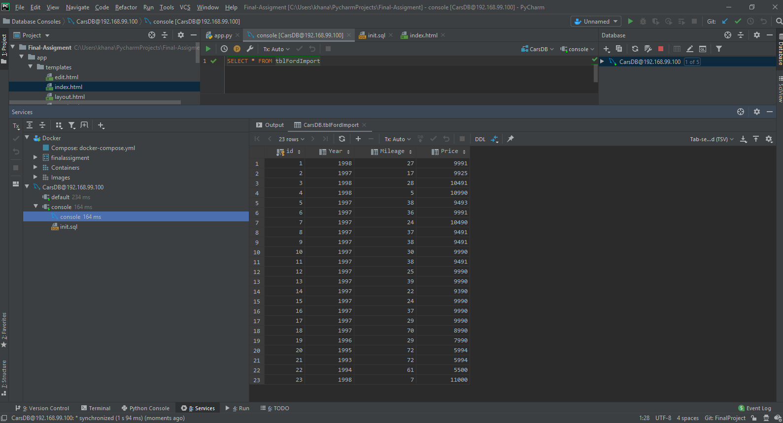

**Browser Homepage with Data**

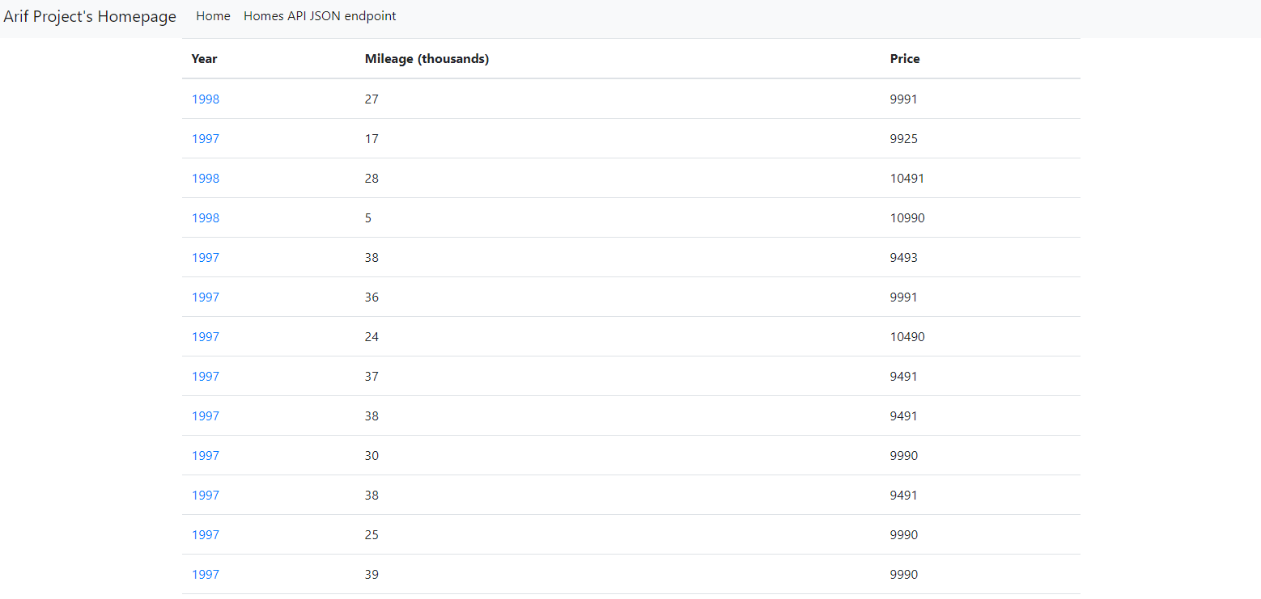

**View of One Record**

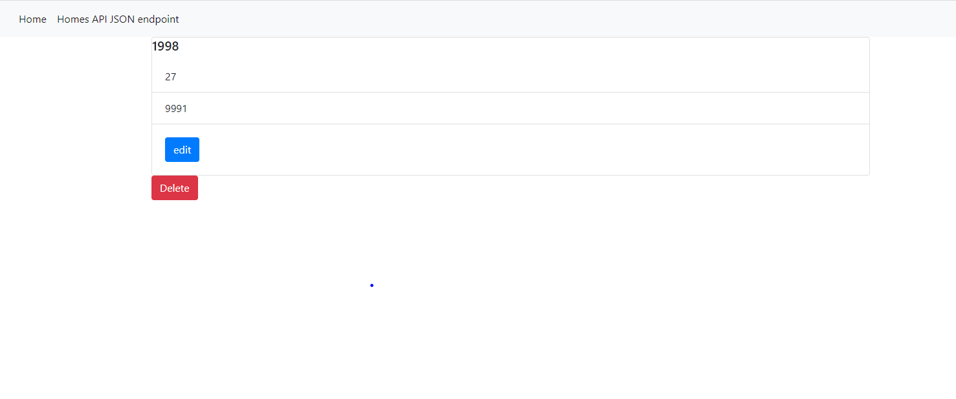

**View of a New Record**

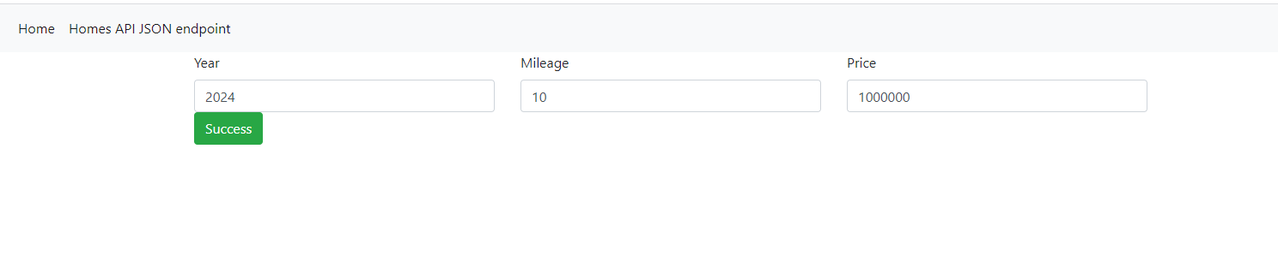 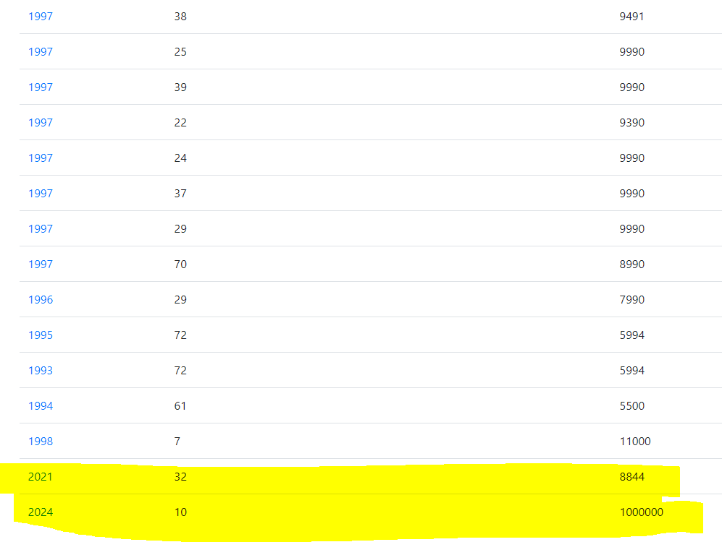

**View of a Deleted Record**

**Before (Delete)**

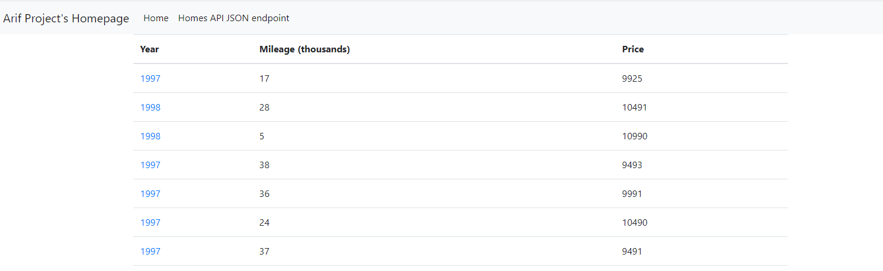

**After (Delete)**

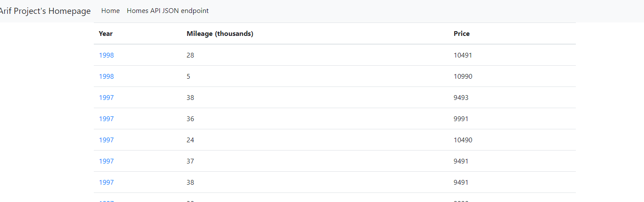

**View of an Updated Record**

